|  |  |  |
| --- | --- | --- |
| Name | **Abdulaziz Alhumidi** | |
| Word Count | **Task 1** | **2307 words** |
| **Task 2** | **1250 words** |
| Cohort | **December 2022** | |
| Unit | **5CO03 - Professional behaviours and valuing people** | |
| CIPD membership no | **86600955** | |

Table of Contents

Task 1 4

AC 1.1 Appraise what it means to be a people professional. 4

AC3.1 Explore how the role of a people professional is evolving and the implications this has for continuing professional development. 4

AC 1.2 Recognize how personal and ethical values can be applied in the context of people practice. 6

AC 1.3 Consider the importance of people professionals contributing to discussions in an informed, clear and confident way to influence others. 7

AC 1.4 Recognize when and how you would raise matters which conflict with ethical values or legislation. 9

AC 2.1 Argue the human and business benefits of people feeling included, valued, and fairly treated at work linking to related theory. 10

AC2.2 Discuss strategies for designing and ensuring inclusive people practices. 11

Task 2 13

Activity1 13

AC3.2 Assess your strengths, weaknesses and development areas based on self- assessment and feedback from others. 13

AC2.3 Reflect on your own approach to working inclusively and building positive working relationships with others. 20

Activity2 20

AC3.3 Formulate a range of formal and/or informal continuing professional development (CPD) activities to support your learning journey. 20

Activity 3 22

AC3.4 Reflect on the impact of your continuing professional development activities on own behaviour and performance. 22

Appendix 26

Task 2 – Activity1 CIPD Assessment Evidence. 26

Ethical Practice: 26

PROFESSIONAL COURAGE AND INFLUENCE 26

Valuing People 26

WORKING INCLUSIVELY 27

PASSION FOR LEARNING 27

Emails from two peers 28

Peer 1 28

Peer 2 29

Task 2 – Activity 2 PDP. 30

References 32

# Task1

## AC1.1 Appraise what it means to be a people professional.

The term professional typically refers to when people work within a profession with a scope of knowledge and skills that let them perform to certain standards (Perez, 2019). It is also about presenting oneself and the way of behaving and espousing the key values (Herrity, 2023). Therefore, a professional is the person who have a knowledge base, skills, espoused values or key behaviors that enable them to work in the world of business.

A people professional is someone who has specialized knowledge, with certain skill-set, and personal values and behaviors and interact with and support people. Professionals need to be affiliated with a professional body to provide the knowledge base and the code of conduct by which people professionals abide by. CIPD introduced its profession map that show people professionals the core knowledge, skills, values, and behaviors they should possess. CIPD profession map introduces core behaviors for people professionals to work and live principles-led, outcome-driven, evidence-based working lives(CIPD, n.d.).

Valuing people and working inclusively, for example are two core behavior in the people profession map.

Dealing with people equally and identifying own biases and challenging them is a core value for a people professional. Empathy with others is understanding of their perspectives and emotions and putting oneself in their positions. It enables individuals to relate to others that can help building relationship and mutual trust. Empathizing with others helps creating a culture of fairness and professionalism.

In the world of business, however, it is highly tempting to focus on making profits and forget about applying personal and professional values amongst the various challenges. This practice is an unethical one that contradicts with professional standards.

## AC3.1 Explore how the role of a people professional is evolving and the implications this has for continuing professional development.

In the world of knowledge and skills-based work, continuous professional development (CPD) is not an option; it is a must. Especially with people practice which is on a steep changing curve nowadays. The UK’s CPD certificate center defines the CPD as the lifelong commitment towards developing own skills through engaging in learning activities (CPD, n.d.). It enables individuals to be proactive and have a passion for learning and develop their own skills. To gain the most of CPD, it needs to be coupled with reflective practice.

Reflective practice in general is the learning form experience through reflecting of what we had done in the past and learn from it in future situations (Top Hat, n.d.). When an individual engages in a learning activity, they should reflect on it: what they learned from that activity, what should have done better, and what can be done in the future to gain the most benefits from learning activity.

The new CIPD profession map introduced new knowledge and principles like business acumen and evidence-based practice respectively (peopleprofession.cipd, n.d). That had a great impact on people professional’s CPD: increasing the areas which they need to learn about in addition to upskilling their current skill set. People professional, for example, now need to be commercially driven and recognize the commercial context and the business environment in which the organization operates. In other words, they should have an outside-in perspective (Ulrich, 2019). Moreover, in the big data era, and with evidence-based practice, people professionals must not neglect the power of data analysis and the field of people analytics. The changing nature of people professional work, therefore, has a great impact on learning activities and CPD of people professionals urging them explore new areas that have not explored before.

Effective CPD should have certain characteristics:

* Continuous: It is a life-long process of learning and developing.
* Personalized: It should be based on any skills gap addressed, and it should enforce strengths as well.
* SMART: The learning objectives should be smart ones.
* Reflective: Individuals should reflect on their CPD to measure its viability with their career and personal development as well.

## AC1.2 Recognize how personal and ethical values can be applied in the context of people practice.

Ethical values are the principles people live individually, or the how the business run on a corporate level (Sherman, 2020). They provide the moral compass through which decisions are made and dictate drive human behavior because it is the right thing to do (CIPD, 2019). These values reflect the belief system about what is morally acceptable and what is not, what is right and what is wrong. Working unethically does not only raise the red flag about organization’s behaviors, but it also impacts the business in terms of employee retention and performance (Baker, 2022).

Personal values that are applicable to people professional that could impact people professional work and their relationship with others are, for example:

* Integrity:

Integrity is the adherence to a code of conduct or a professional ethical standard. It is about being honest and accountable for making mistakes and rectifying them. Showing honesty at work is a fundamental ethical value that could improve working practices. For example, employees who lack the ability of doing task and asks for help and admit mistakes when they happen help increasing performance and teamwork. They also gain trust, respect, and good reputation among their colleagues.

* Fairness

Fairness is the value of being just and impartial and treat people from an equal distance. People professional must espouse fairness in the workplace as it has a significant impact on relationship within workplace and how work is done. Opportunities for advancement, for instance, should be provided for people on just basis. When employees perceive equal treatment based on fair policy, they would be more committed to their work and more engaged. Unfair working values, however, would lead to alienated and disengaged employees.

* Valuing people:

Valuing people is an essential principle in people practice professional life. It refers to the fact that all people are equally treated and deserve respect, dignity and consideration. It helps to create an environment of diversity and inclusion in the workplace which has a great benefit for the organization in terms of abiding by legislation, better decision making, creativity and innovation. It creates a sense of trust between coworkers and the organization alike.

## AC1.3 Consider the importance of people professionals contributing to discussions in an informed, clear and confident way to influence others.

~~One of the key behaviors in the CIPD profession map that could be espoused by a people professional is the courage to influence others (CIPD, n.d.). It is an essential behavior for a people professional to build a strong business case and be able to influence stakeholders. For building a strong business case, people professional must have the necessary tools to lead an informed, clear and confident discussion to influence others. Changing the recruitment policy and procedures that has issues with core values like transparency and respecting others, for instance, requires a bold people professional to challenge the status quo and call for a change.~~

*~~Informed discussion:~~*

~~One of the key people practices is making decisions or arguing based on solid evidence that prove evidence-based practice. People professionals should not make decisions or arguing based on opinions and views; their arguments are based on evidence. Based on French and Raven's forms of power, people professional have the power of information and knowledge to influence others (mind tools, n.d.). To utilize the power of evidence-based arguments, people professionals need to collect all relevant information about the deficiency of the current policy and how to fix it.~~

*~~Clear discussion:~~*

~~To demonstrate a clear discussion to influence others, people professional could use the divide and conquer principle. Dividing the bigger picture or the whole argument into smaller parts helps make it clear. Giving a bird eye view about the discussion and cascading down to discuss small issues one in a turn, and then summarizing and collecting all together at the end of discussion makes it clear to the audience.~~

*~~Engaging discussion:~~*

~~To engage stakeholders during discussing changing recruitment policy, it is a fundamental practice to leave a room for feedback and thoughts. For stakeholder to be engaged, the discussion should be back and forth, not a lecturing style. Additionally, presenting active listening skills during the discussion makes it more engaging.~~

One of the key behaviors in the CIPD profession map that could be espoused by a people professional is the courage to influence others (CIPD, n.d.). It is an essential behavior for a people professional to build a strong business case and be able to influence stakeholders. In an organization I used to work for in Saudi Arabia, they had an annual party for celebrating the achievements of the year. The policy for motivating employees to go forward is to grant them an annual bonus. To adapt the equality and fairness, they were giving each and every employee a bonus salary no matter what. I thought this was not fair even if all employees were equal. In that way, some employees might think that they will get their salaries and bonuses whether they worked hard or otherwise. In addition, that would demotivate hard workers. That practice was not a good people practice and resulted in reverse outcomes of declining performance.

The good people practice, however, was to link the reward system (bonus) to employee’s performance which would enhance fairness, boost performance of middle performers and motivate hard workers. I suggested a reward scheme for the employees based on performance in which there was a guideline for the bonus. For example, who gets 90% and above in their performance appraisal gets a bonus salary, who gets between 70% and 89% will get 20-day salary and so forth.

*Informed discussion:*

Based on French and Raven's forms of power, people professional have the power of information and knowledge to influence others (mind tools, n.d.). Using theories of performance like Herzberg’s theory (Nickerson, 2023), that proves that the current practice is a clear demotivator for hard workers, and data on performance of employees which show declining performance, the suggestion was backed up with solid evidence.

*Clear discussion:*

Using the evidence for the claim and demonstrating that the reward system was the cause of declining performance of even those who used to be hard workers, the discussion was clear.

*Engaging discussion:*

The discussion was helping to solve a problem in the workplace, and in addition to active listening and building rapport techniques, the discussion was engaging.

## AC1.4 Recognize when and how you would raise matters which conflict with ethical values or legislation.

An example in which there was a conflict with ethical and social values is when a university professor tried to sexually harass one of his female students. A university professor in Saudi Arabia managed to get the phone number of a female student with the help of an employee who works in admission and registration department in the university. In a conservative society like Saudi Arabia, this behavior is unacceptable on all levels: ethically, socially, and on legislation level. Both the professor and the employee who released the student’s information (phone number) have committed an unacceptable behavior.

Whistleblowing policy is a policy to protect the whistleblower – the person who raises the concern about wrongdoing (whistlelink, 2020) – from any victimization or unfair dismissal (Homann, 2022). Saudi government introduced a royal decree to protect the whistleblower who report unethical and illegal behaviors in workplace. The National Anti-Corruption Commission (Nazaha) are taking extra measures to protect the whistleblowers (Alissa, 2020).

Hence, the incident was reported to human resources manager, who in turn reported to higher management (college dean and board of trustees) for investigation. A committee was formed to investigate the incident to take an action after hearing from the employee and the professor. The conversation was an accusation, and both could not deny the incident: the employee admitted that he released sensitive student’s information, and the professor confessed that he wanted the phone number for unethical purposes i.e., for harassment. They both agreed that that behavior is not acceptable ethically or legally. The committee decision was a dismissal for both employees without notice.

## AC2.1 Argue the human and business benefits of people feeling included, valued, and fairly treated at work linking to related theory.

When people feel included, valued, and treated fairly on an ethical basis, many benefits result from an employee as well as organization perspectives including job satisfaction, higher level of performance, lower level of absenteeism.

According to Self-Determination Theory (SDT), there are three basic needs for individuals that derive their intrinsic motivation (Ackerman, 2018). The three needs are autonomy, competence, and relatedness. Autonomy is the need to control one’s own life, and in terms of world of work, the need to control the way of working. Competence is the need to be competent in what individuals do, while relatedness is the need for affiliation and having relationship with others.

Fulfilling these basic needs help employees fell included, valued and treated fairly on ethical basis. Employees can feel valued when they are autonomous and have control over their job they are doing. Similarly, they feel valued and included when they receive constructive feedback about their performance. Also, when employees treated fairly at workplace, they feel that they are connected to their colleagues and the need of relatedness is fulfilled. Satisfying basic needs of employees and when they feel they are valued, included, and treated fairly, job satisfactions hikes, and hence employee retention; they would not seek another place to satisfy their needs.

From the business perspective, employees with higher job satisfaction are more productive and promoter to the employer brand. In other words, satisfied employees are willing to recommend their organization to others. Research showed that belonged employees showed 167% increase in their employer promotor score (Carr, Reece, et al., 2019). Further results from the research showed that employee belonging linked to increased job performance by 56%, lowering the employee turnover by 50% and a 75% reduction is sick days.

## AC2.2 Discuss strategies for designing and ensuring inclusive people practices.

Inclusion is a fundamental people practice principle and it means giving voice to all relevant stakeholders in a particular initiative. There are several ways out there to collect feedback from relevant stakeholders like online surveys, focus groups, interviews, etc.

Employee turnover is a serious problem that faces organizations and costs them time and money. The available data of turnover figures indicate that there is a problem that needs intervention. To face the problem, people practitioners first need to collect data using different methods to ensure inclusion of all relevant stakeholders. Exit interviews are an essential part of the tool kit in hand to determine the problem and fix it. Although it is historical data, it is very useful to focus on the problem. Next, focus groups including line managers and people professionals to brainstorm potential reasons behind high turnover rate. Moreover, employee satisfaction survey gives a great indication about employee satisfaction scores, which will complement the data in hand.

Consolidating and analyzing that data give a bird eye view about the situation, and through further investigation the potential reasons reveal. Assuming that the most significant reason for high turnover rate is insufficient learning and development activities that support career progression. Consequently, the problem is clear, and the solution is to introduce fair policy for Learning and Development activities based on solid performance management system. To ensure inclusion, a training needs analysis is conducted for all staff based on which L&D programs are designed.

After the intervention, the data should be collected to check the viability of the solution. The turnover rate after the intervention is a clear measure of the solution. In addition, employee satisfaction survey is conducted and compared with the scores before the intervention. Line managers should also be listened to so that they give feedback about the success of the initiative.

# Task2

## Activity1

### AC3.2 Assess your strengths, weaknesses and development areas based on self- assessment and feedback from others.

Using self-assessment tool provided by CIPD and in addition to feedback from two colleagues whom I used to work with recently, I have my strengths and weakness in the core behaviors in CIPD procession map (complete assessment in the appendix), and they are as follows:

|  |  |  |
| --- | --- | --- |
| Behavior | Strength | Weakness |
| Ethical Practice | Decisions made are informed by applying professional values. | Inability to challenge practices that are against professional or legal values |
| Professional Courage and Influence | Courage to admit mistakes and rectify them. | Inability to engage others to build a strong business case. |
| Valuing People | Dealing all people and stakeholders with respect and listen to them regardless of their tier or position. | The courage to show my opinion about actions others do. |
| Working Inclusively | Good Listening skills. | Inability to handle conflicts. |
| Passion for Learning | Ability to have up-to-update knowledge. | Reluctance to ask for feedback. |

### AC2.3 Reflect on your own approach to working inclusively and building positive working relationships with others.

Feedback from others and self-assessment using CIPD online tool shows that I have a strength of valuing people and work with them inclusively so that I build a positive relationship with everybody. My approach to that is to deal with everybody in the same way I like to be dealt with. Showing respect to literally everybody regardless of their position, age, gender that builds towards inclusive and positive relationship. People whom I respect, and value show the same in return which builds a positive working relationship with others.

## Activity2

### AC3.3 Formulate a range of formal and/or informal continuing professional development (CPD) activities to support your learning journey.

According to Kolb and Honey & Mumford, there are different learning styles that differ from an individual to another; everyone has their own preferred way of learning. Learning interventions, however, need to have a wide range of methods so that learner benefit from it as much as they possible can (CIPD, 2021). Consequently, having a variety of learning activities would be helpful to acquire the most knowledge and skills possible. To support my learning journey, which is based on my areas for improvement, I have chosen a range of formal, informal, and self-directed learning approaches to inform my learning journey. The complete Professional Development Plan (PDP) is in the appendix.

*Passion for learning:*

To improve my passion learning, the chosen method here is a structured way of learning through getting the CIPD qualification. Having a structured style to learning through a formal qualification have several advantages over the self-directed learning. There will be a community through which there is a change of sharing knowledge and experience. In addition, there would be professional feedback to inform the progress of my learning.

*Professional courage and influence:*

To develop my professional courage and influencing others, I have a different approach which is self-directed way of learning. There are several activities that could be used in self-directed learning. For example, attending an online course that suits my own pace or reading a book. Here I will attend a course from CIPD learning hub and read a book about effective HR communication to inform my professional courage to communicate.

Managing Conflicts:

To improve my skills in managing conflicts, there is a mixture of learning styles which are self-directed learning of building theoretical knowledge through reading about the topic and an informal way of learning through shadowing somebody else to acquire certain skill.

## Activity3

### AC3.4 Reflect on the impact of your continuing professional development activities on own behaviour and performance.

To learn from experience, one must reflect on that experience and learn what went well and what could be done better in the future. Gibbs' Reflective Cycle is a useful model to lead the reflection process (Mind Tools, n.d). Here I will reflect on three learning activities I did in the last 12 months.

* Data Analysis Skills:

**Description:**

By June 2022, my organization applied for an accreditation process which requested lots of retrospective data analysis that was required from me. We were supposed to work on requirements before the accreditation body visit at the beginning of 2023. I had some excel and data analysis skills, but it did not suffice the huge project. I decided to enroll for a data analysis course that can boost my confidence.

**Feeling:**

I felt that my data analysis skills made it hard for me to provide the required information in an easy way; I was struggling a bit. I researched the internet for a data-analysis course to help me out and I found that google provides one that lasts for six months.

**Evaluation:**

The course was great, and I enjoyed the field of data analysis. After the course, I am a confident data analyst who the department can rely on.

**Conclusion:**

I started from some humble excel knowledge to an intermediate data analyst, thanks to google course. In the future, I will use my analytics skills to inform decisions by the department.

**Action:**

I was able to analyze the data and provide the required reports.

* Performance Management System.

**Description:**

Last year (September 2022) when I was assigned to develop a robust management system that does not only depend on performance appraisal as a tick box exercise, but I was also asked to conduct a lecture to my peers about PMS to be implemented.

**Feeling:**

I felt intimidated as I had no idea about PMS as a holistic approach, not just a performance appraisal at the end of the year. So, I had to learn about an effective management system to do what I was asked for. First, I browsed the web for articles about PMS and I felt that I am collecting some information here and there in an unstructured way. Then I read a book chapter titled “Introduction to Human management Practice” by Leatherbarrow and Fletcher and a book titled “Human Resource Management” by Dessler. By then, I felt more confident about my knowledge of PMS and completed my knowledge from browsing articles.

**Evaluation:**

The learning process went great after having a bird eye view about the topic, although it was difficult and unstructured at the beginning. I got one week (second week of September) for finalizing the whole learning process which is too long. In the future, I should read a book chapter, based on which I start structuring my learning process. The two chapters enabled me to collect information on a more structured way. I was able to conduct the lecture to my peers, and it went great.

**Conclusion:**

By that time, I was well acquainted with PMS process and conducted the lecture. It helped us use that learning in PMS.

**Action:**

I was able to provide the lecture to my peers and all of us was informed by the knowledge to come up with PM policy.

* Interviewing Skills:

**Description:**

In February 2023 when my manager was on leave, I had to conduct some job interviews, and my interviewing skills were not up to standards. I asked the help from my manager to shadow him to acquire interviewing skills. After his holiday, we planned two months shadowing scheme in which I would attend all job interviews to acquire that skill.

**Feeling:**

I felt unconfident conducting interviews at the beginning and sough help. Gradually after some interviews I started to gain confidence.

**Evaluation:**

The experience was great and helped me conduct interviews myself.

**Conclusion:**

In the future, I will use what I learnt by conducting job interviews.

**Action:**

I will advance my knowledge about the topic by further reading.

# Appendix

## Task 2 – Activity1 CIPD Assessment Evidence.

### Ethical Practice:

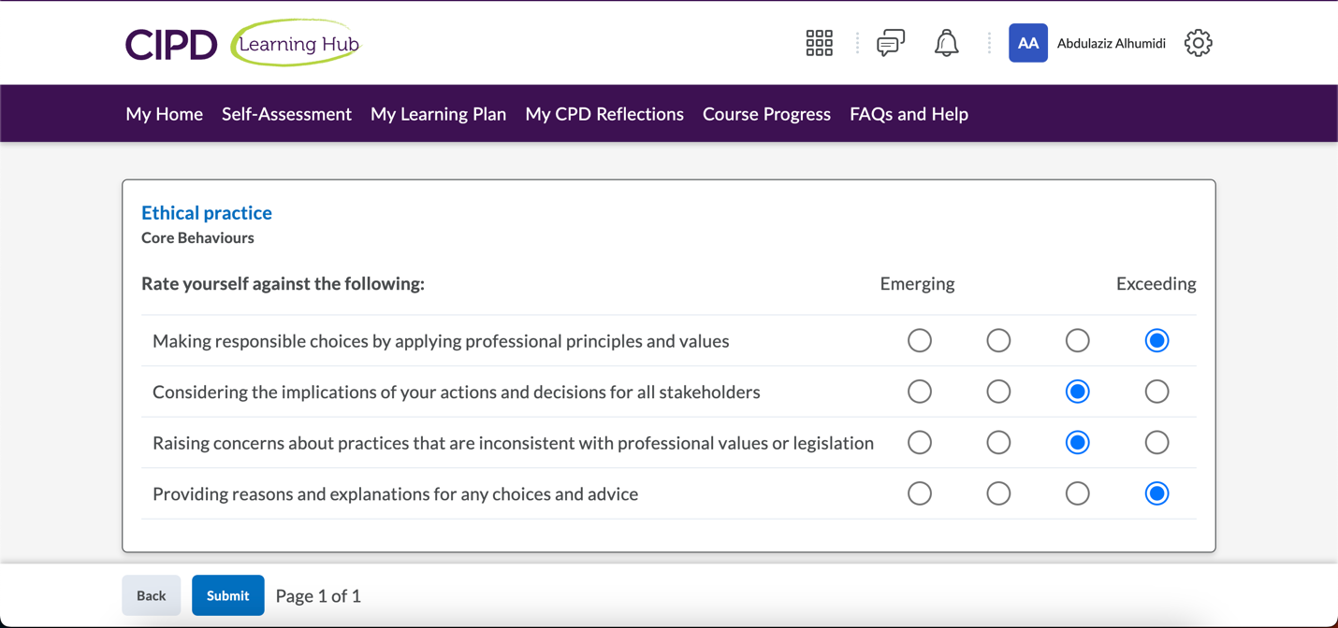

### PROFESSIONAL COURAGE AND INFLUENCE

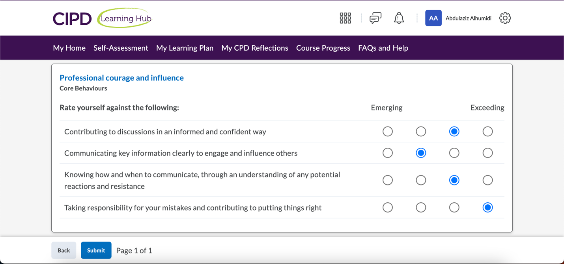

### Valuing People

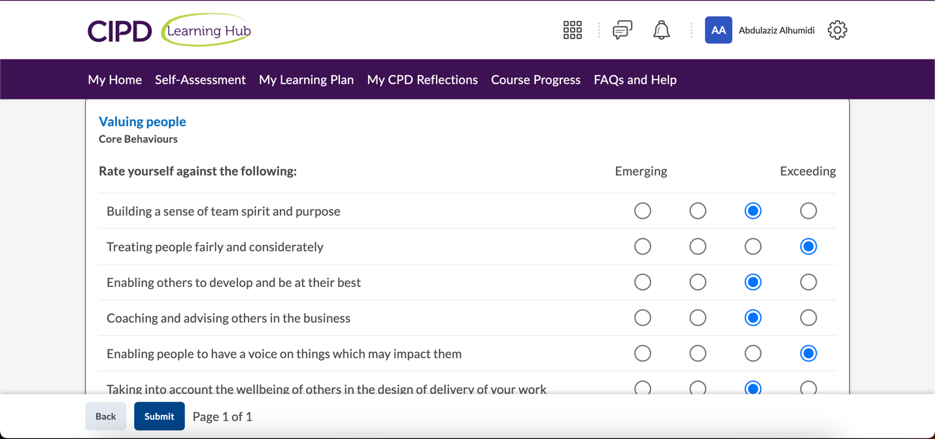

### WORKING INCLUSIVELY

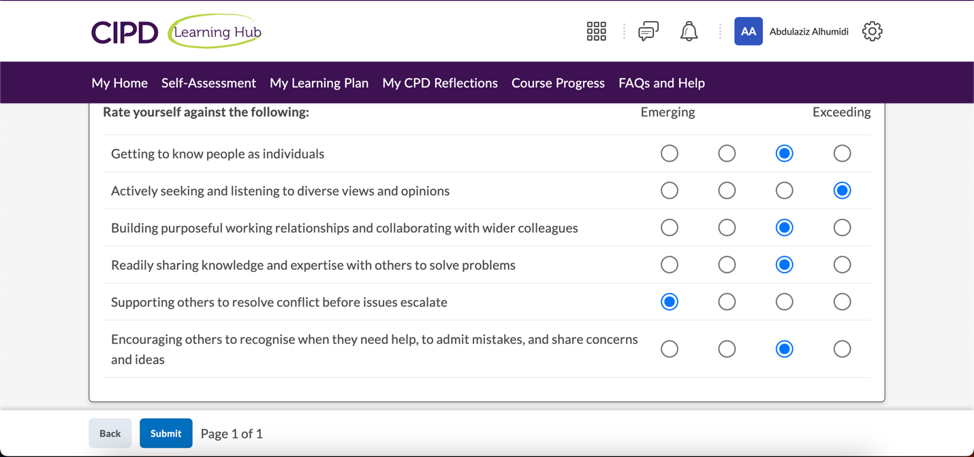

### PASSION FOR LEARNING

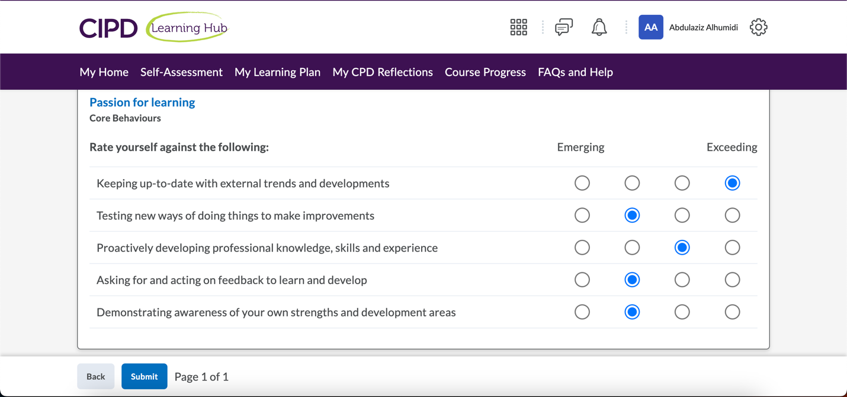

## Emails from two peers

I have recently moved to another organization where colleagues are not well-acquainted with me. I asked my colleagues in my previous organization

### Peer 1

An employee in Project Management Office

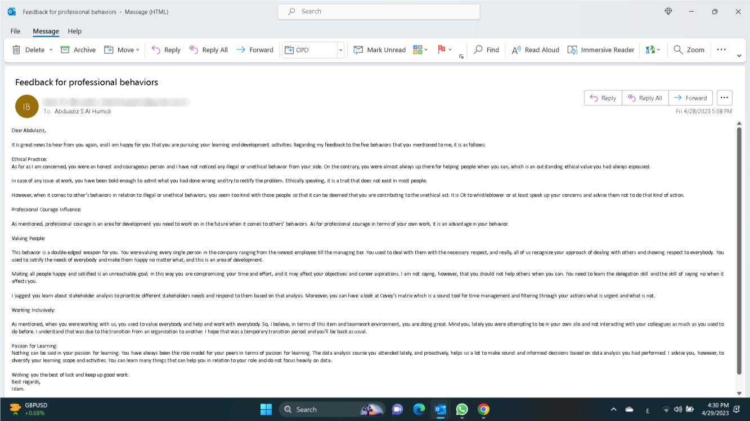

### Peer 2

My colleague in HR department

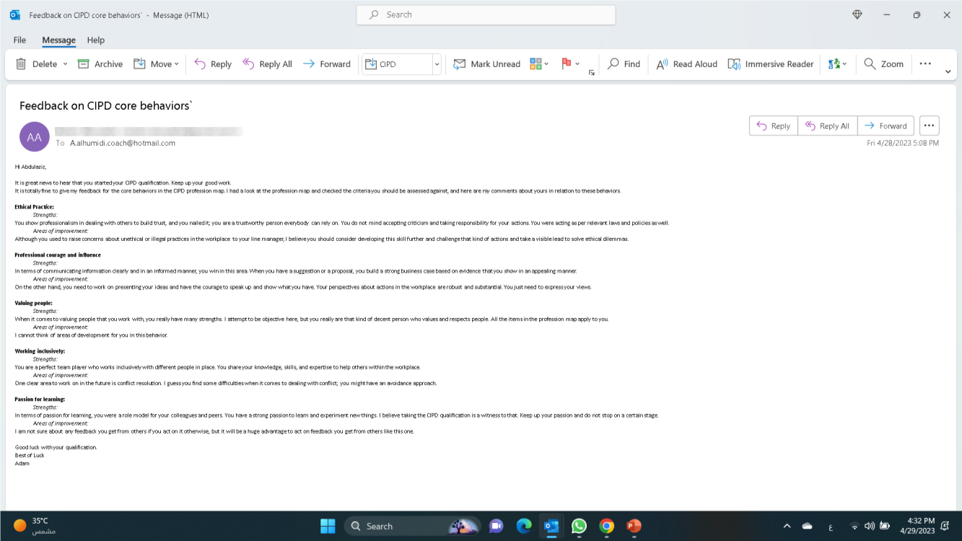

## Task 2 – Activity 2 PDP.

|  |  |  |  |  |
| --- | --- | --- | --- | --- |
| **What do I want/need to learn?** | **What will I do to achieve this?** | **What resources or support will I need?** | **What will my success criteria be?** | **What are my target dates for review and completion?** |
| Proactively developing my professional knowledge and skills in the area of learning and development. | Finalize CIPD qualification level 5 L&D. | CIPD course which I already enrolled in. | * Finish the course with passing all modules. * Personal satisfaction about the knowledge and skills gained | Finishing the CIPD qualification by mid-November. |
| Professional courage and influence: effectively communicate with people and have the courage to speak up and express my views about different issues. | * Attend CIPD course about professional courage and influence. * Ask my peers for feedback about my courage to share information and views about certain issue. * Read the book recommended by CIPD assessment tool ‘Effective HR Communication: A Framework for Communicating HR Programmes with Impact’. | * The learning material from CIPD website which is already available on my account. * Support from my peers to provide the feedback when necessary. * The book which is mentioned in my learning recommendations. | The success criteria for such behaviour would be both internal and external.  Internal is how I feel expressing my own views and have the courage to speak up in front of others. When I will be able to express my views freely, that would be a success.  External success criterion would be the feedback I receive from others. | I will dedicate one-week time for the course and another week for reading the book after finishing my CIPD qualification which will end by mid-November 2023. So, I expect to complete this activity by end of November 2023. |
| Managing conflicts effectively | To acquire the skill of managing conflicts effectively, I need to develop some theoretical knowledge about how to manage conflicts in the workplace that are available on CIPD website.  Moreover, manging conflicts is a skill that requires a hands-on experience. Consequently, shadowing somebody would be more effective in that situation. Managing my manger would be helpful., | The resources that I need is the theoretical knowledge which is accessible on the CIPD website.  In addition, I need the support of my manager who will help me shadow her. | The success criteria would be effectively managing a conflict alone without help from anybody. | I will dedicate a month for the theoretical knowledge, and after that the shadowing would be arranged with my manager.  The expected date for finishing theoretical knowledge would by be end of December 2023. |

# References

Perez R., (2019) *What Does It Mean to Be a Professional?* Available at <https://journals.lww.com/professionalcasemanagementjournal/fulltext/2019/07000/what_does_it_mean_to_be_a_professional_.7.aspx> [Accessed on 09 April 2023].

Herrity J., (2023) What Does It Mean to Be Professional? <https://www.indeed.com/career-advice/career-development/what-does-it-mean-to-be-professional> [Accessed on 09 April 2023].

CIPD (n.d.) Explore the profession map Available at <https://peopleprofession.cipd.org/profession-map> [Accessed on 09 April 2023].

CPD (n.d.) *What is Continuing Professional Development (CPD)* Available at <https://cpduk.co.uk/explained> [Accessed on 24 April 2023].

Top Hat (n.d.) *Reflective Practice* Available at <https://tophat.com/glossary/r/reflective-practice/> [Accessed on 24 April 2023].

People Profession CIPD (n.d.,) *Explore the Profession Map* Available at <https://peopleprofession.cipd.org/profession-map> [Accessed on 24 April 2023].

Ulrich D., (2019) *HR from the Outside-In* Available at <https://www.rbl.net/insights/videos/hr-from-the-outside-in> [Accessed on 24 April 2023].

Sherman F., (2020) *Definition of Business Ethical Values* Available at <https://smallbusiness.chron.com/definition-business-ethical-values-21096.html> [Accessed on 11 April 2023].

CIPD (2019) *Ethics at work: employer’s guide (*Report*)* Available at <https://www.cipd.co.uk/Images/7919-ethics-guide_tcm18-66759.pdf>  [Accessed on 11 April 2023].

Baker C., (2022) *What Are Ethical Values in Business?* Available at <https://leaders.com/articles/company-culture/ethical-values/> [Accessed on 11 April 2023].

Mind tools (n.d.) French and Raven's Five Forms of Power Available at <https://www.mindtools.com/abwzix3/french-and-ravens-five-forms-of-power> [Accessed on 13 April 2023].

Nickerson C., (2023) Herzberg’s two-factor theory of motivation-hygiene Availabe at <https://www.simplypsychology.org/herzbergs-two-factor-theory.html> [Accessed on 21 May 2023].

Whistlelink (2020) *What is whistleblowing?* Available at <https://www.whistlelink.com/blog/what-is-whistleblowing/> [Accessed on 22 April 2023].

Homann M., (2022) *What is Whistleblowing in the Workplace? FAQ for Companies* Available at <https://www.integrityline.com/expertise/blog/what-is-whistleblowing/> [Accessed on 22 April 2023].

Alissa N., (2020) *Whistleblowers in Saudi Arabia* Available at <https://nasreenalissalaw.com/en/whistleblowers-in-saudi-arabia/> [Accessed on 22 April 2023].

Ackerman C., (2018) *Self Determination Theory and How It Explains Motivation* Available at <https://positivepsychology.com/self-determination-theory/> [Accessed on 23 April 2023].

Carr E., Reece A., et al., (2019) *The Value of Belonging at Work* Available at <https://hbr.org/2019/12/the-value-of-belonging-at-work> [Accessed on 23 April 2023].

CIPD (2021) *Learning theories for the workplace* Available at <https://www.cipd.org/uk/knowledge/factsheets/learning-theories-factsheet/> [Accessed on 28 April 2023].

Mind Tools (n.d.,) *Gibbs' Reflective Cycle* Available at <https://www.mindtools.com/ano9qiu/gibbs-reflective-cycle> [Accessed on 29 April 2023].